MEETING DATE: | September 27, 2022 | ITEM NUMBER: 12.{{item.number}}

SECOND READING: |  | {{customfields.ResoOrdNumber}}
TYPE OF ITEM: General Business
PRESENTED BY:
Harold Dominguez, City Manager's Office, Harold.Dominguez@longmontcolorado.gov
Jim Golden, Finance Administration, Jim.Golden@longmontcolorado.gov
Teresa Molloy, Budget, Teresa.Molloy@longmontcolorado.gov
Other City Staff

SUBJECT/AGENDA TITLE:
2023 Budget Discussion and First Public Hearing

EXECUTIVE SUMMARY:
The Proposed 2023 Budget presentation will focus on the categories of the three topics that were delayed from September 20 (early childhood capacity building, 529 Jump and supporting actions for mental health), priority based budgeting and the 2023 budget, financial policies, and the Public Safety take home vehicle program. Council will also need to hold the first public hearing on the 2023 Proposed Budget and the 2023-2027 Proposed Capital Improvement Program. This communication includes a brief overview of each topic and has been consecutively numbered. This information will be available on the City’s website with the 2023 proposed budget documents should we need to refer back to any information from this communication as we continue to move through the weekly 2023 budget presentations.
https://www.longmontcolorado.gov/departments/departments-e-m/finance/budget-office/2023-budget-documents

COUNCIL OPTIONS:
Click or tap here to enter text.

RECOMMENDED OPTIONS:

FISCAL IMPACT & FUND SOURCE FOR RECOMMENDED ACTION:

BACKGROUND AND ISSUE ANALYSIS:
Citizens wishing to view the 2023 Proposed Budget, the 2023-2027 Proposed Capital Improvement Program or the 2023 Proposed Pay Plan can access these documents on the City’s website at the following location:
https://www.longmontcolorado.gov/departments/departments-e-m/finance/budget-office/2023-budget-documents

ITEMS DELAYED FROM SEPTEMBER 20 MEETING
The following items originally planned for September 20 will be covered during this meeting:

Early Childhood Capacity Building
This information was included in the September 20 communication on page S-64.

529 Jump
This information was included in the September 20 communication on pages S-64 and S-65.

Supporting Actions for Mental Health
This information was included in the September 20 communication on pages S-65.

PRIORITY BASED BUDGETING AND THE 2023 BUDGET
Since 2013 the City Council has made a commitment to use priority based budgeting to make decisions regarding resource allocations. A key component of the priority based budgeting process is to identify the results that the City is in business to achieve. Initially the City used the Focus on Longmont strategic policy directions to identify the desired results. Starting in 2014, all of the programs of the City were identified, costed and scored based on how they influence the desired results as well as the key Basic Program Attributes: mandate to provide the program, reliance on the City to provide the program, cost recovery of the program, and portion of the community served by the program. Each individual program has an overall score based on its influence on these results and attributes that places it in one of four quartiles. Since 2014, in our annual budget processes staff has used this information to evaluate budget requests. As there are limited resources available the intent is to ensure that our new resources are going toward programs in the higher quartiles. With limited exceptions most new resources that go toward fourth quartile programs are for salary and benefit increases for employees who are part of existing programs.

In 2016 the City Council adopted Envision Longmont, a multimodal and comprehensive plan that provides strategic direction and guidance for Longmont over a period of 10 to 20 years. Both the priority based budgeting process and the Envision Longmont process include community input toward goals and priorities. Envision Longmont includes six guiding principles that reflect key elements of the community’s desired future. These guiding principles provide focus in terms of where efforts and resources should be directed over 10 to 20 years to ensure that Longmont remains a livable, prosperous and attractive community. During the first half of 2018 the staff worked to incorporate the Envision Longmont guiding principles into the priority based budgeting process. This included the involvement of the City Council and the community along with a diverse representation of City staff. We now are using the guiding principles from Envision Longmont as the desired results in priority based budgeting. The guiding principles and their relative priority weightings as determined by the community are:

- Livable centers, corridors and neighborhoods 17.1%
- A complete, balanced and connected transportation system 12.2%
- Housing, services, amenities, and opportunities for all 20.3%
- A safe, healthy, and adaptable community 17.7%
- Responsible stewardship of our resources 16.0%
- Job growth and economic vitality through innovation and collaboration 16.7%

Maintaining Longmont’s outstanding quality of life has been a long-standing Council goal. To keep Longmont a quality place to live as the economy struggles requires that limited resources are allocated proficiently among multiple priorities.

An overview of the City’s PBB process, including the scoring criteria and the data from prior budgets, and the community PBB model can be found on the City’s website at the following address: https://www.longmontcolorado.gov/departments/departments-e-m/finance/budget-office/budget-prioritization

Below is the Priority Based Budgeting quartile comparison of the 2022 adopted budget and the 2023 proposed budget. These amounts do not include any budgeted amounts for CIP, transfers, debt service, or purchased power. As shown below the 2023 proposed budget has $126.47 million (54.7%) that supports quartile 1 programs and another $47.11 million (20.4%) that supports quartile 2 programs. Attachment M includes the quartile graphs for each major operating fund.

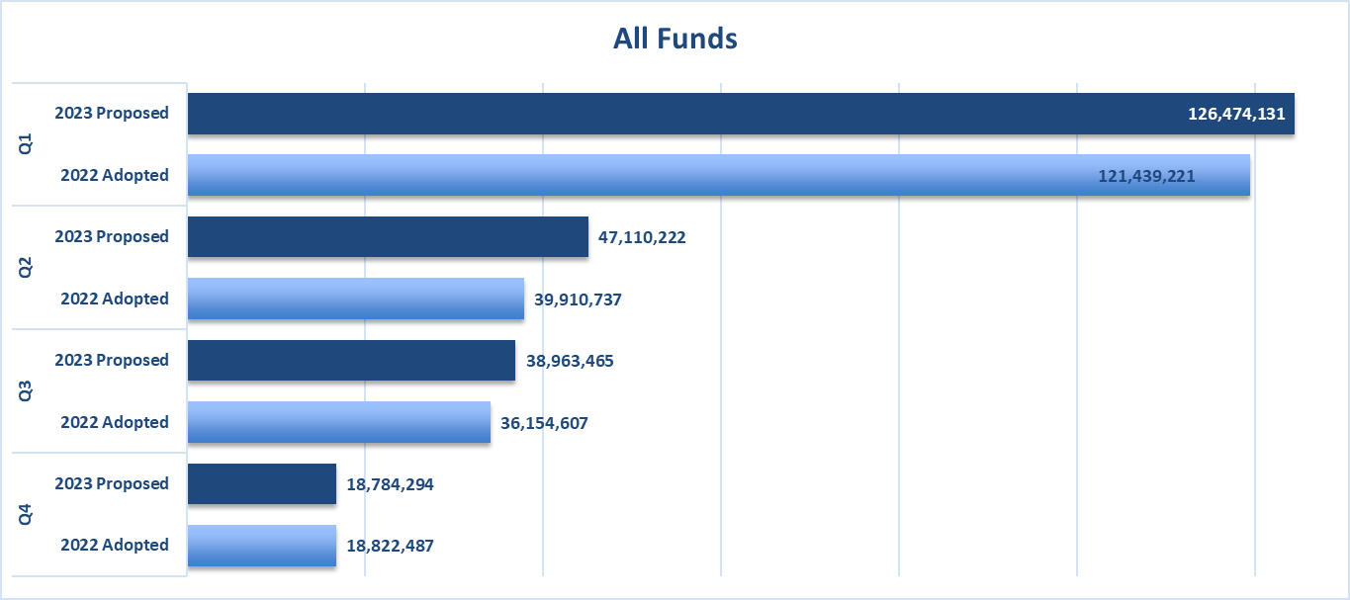

This graph below shows by quartile the Level 1 and Level 2 ongoing increases for the General Fund.

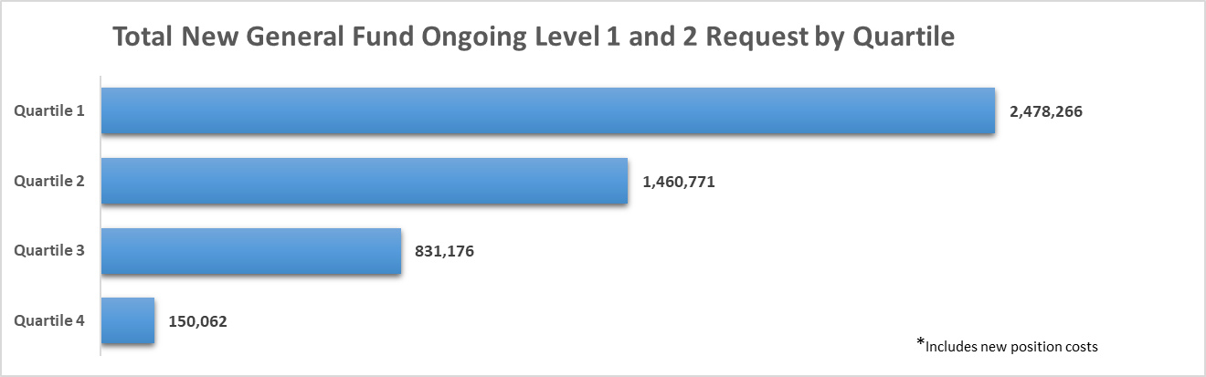

Council previously directed staff to incorporate an equity component into our PBB process. As a first step, for the 2022 budget staff incorporated equity by creating equity insights that allowed us to gather equity information for each program based on the Equity Team’s definitions of the various components of equity support. Each department was asked to evaluate each program against these definitions and provide information on how the equity insight is achieved by the program.

The second step, completed for the 2023 budget, turned these equity insights into a Basic Program Attribute (BPA) fully incorporating equity into our PBB scoring process such that it influences the overall program score and placement within the Quartile matrix. To complete this scoring a budget sub-team within the Equity Team formed a scoring matrix from these equity insights to help create a solid scoring foundation for equity. This team then took on the peer review role and studied the equity insights submitted by the departments during the 2022 budget process. This peer review process included discussions with departments regarding insights for which the sub-team did not agree with the department scoring, with some scores being updated based on input from the sub-team.

The City has a total of 451 programs, all of which were reviewed by the sub-team. As shown below, 7 of these programs received the highest possible score for the equity BPA. These are the programs that support both equitable community and equitable access. Another 146 programs scored a 3, which means they support equitable community or equitable access. The largest number of programs, 156, scored a 2, meaning reductions or eliminations in these programs could disproportionately impact equitable community or equitable access. These are the programs that have more of an indirect impact on equity rather than a direct impact.
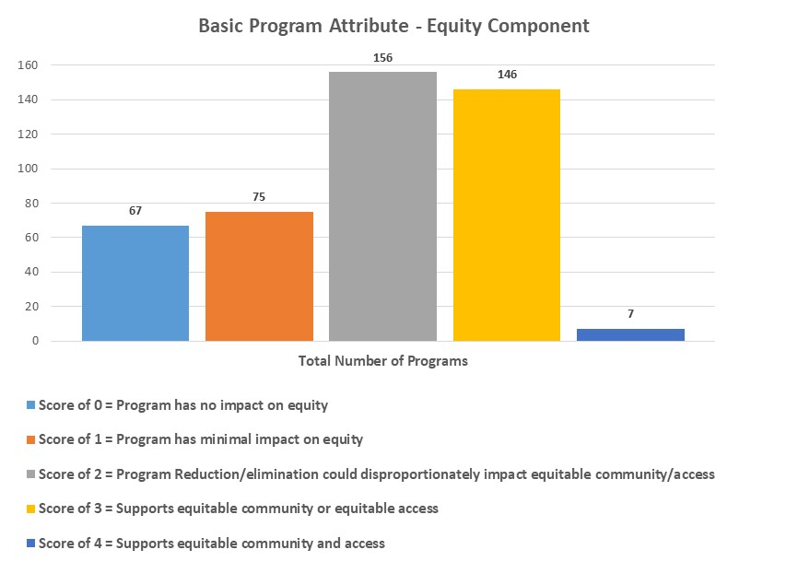

Attachment N is a list of all the community programs and Attachment O is a list of all the governance programs. These attachments show how programs align within the quartiles. Those highlighted in blue are the programs that moved up one quartile while programs highlighted in green moved down one quartile after the equity scoring was incorporated. Programs not highlighted stayed in the same quartile. There are 19 Community Programs that moved up and 1 community program that moved down one quartile. There are 11 Governance Programs that moved down with no programs moving up a quartile.

During the Council meeting we will be reviewing the 2023 Proposed PBB data now that the equity PBA has been incorporated into the program scoring.

FINANCIAL POLICIES
As part of the 2023 budget process staff has reviewed and updated the City’s current financial policies. All changes to the financial policies will be adopted by resolution (scheduled for October 25) and will become effective on January 1, 2023. The complete policies can be found in Attachment P and reflect the proposed changes by using strikeouts for phrases to be removed and bold blue letters for new words or phrases to be added. Various policies include the comment [TO BE UPDATED AFTER THE 2023 BUDGET IS COMPLETED]. After staff receives final direction on the 2023 Operating budget from Council these policies will be revised to include 2023 Budget figures.

Several of the proposed changes recommended by staff are minor updates or clarification of information which do not change the intent of the policy and are not listed in this communication. If Council has questions on any changes, staff will be available to discuss them during the presentation. New policies as well as changes that go beyond updates or basic clarification are highlighted below.

New Policies
One new financial policy is being proposed for 2023, Procurement Thresholds. This policy sets the thresholds to match the federal grant thresholds for non-federal entities receiving federal funds. It establishes one set of standards regardless of the funding source and will mitigate complexity for staff.

Procurement Thresholds
The City will use methods of procurement for City goods, services, and construction in compliance with thresholds as defined in the Purchasing Code (LMC 4.12). The thresholds include (1) micro, for which vendor selection is at the discretion of the end user, (2) small, for which vendor selection requires solicitation of a minimum of three documented quotations, and (3) formal, for which vendor selection requires a formal/sealed competitive solicitation of bids or proposals. The dollar amount for each threshold is included in the Financial Policies for annual review and adjustment as appropriate.

Standard procurement thresholds:
- Micro: up to $10,000
- Small: up to $250,000
- Formal: over $250,000

Procurements valued between $10,000 and $250,000 require solicitation of a minimum of three competitive, documented quotes conforming to the requirements of LMC 4.12, using a sourcing and evaluation method which must be approved by central professional procurement staff prior to issuance of an award.

The City will amend LMC 4.12 in 2023 to (1) remove references to specific dollar amounts attributed to each threshold and (2) update terminology to differentiate between micro and small purchases.

Updated Policies
Staff is proposing the following changes that are more than basic clarifications. These updates will change the intent and/or implementation of the policy:

Public, Educational, and Governmental (PEG) Access Television Services
25% 50% of the General Fund’s budgeted cable television franchise revenues will be allocated for the purposes of providing public, educational, and governmental television services in 2023 and 2024. If the actual cable television franchise revenue collected by the City is greater than ten percent (10%) less than the City’s General Fund’s budgeted cable television franchise revenues, then the contract price shall be twenty-five fifty percent (25 50%) of the actual cable television franchise revenue collected by the City.

The 2022 Operating Budget includes $140,000 for a contract for service with Longmont Public Media. In addition Council approved an additional $120,000 of one time funding for the contract with Longmont Public Media for 2022. [TO BE UPDATED AFTER THE 2023 BUDGET IS COMPLETE]

Health Benefits Fund
The City will maintain an insurance fund for the payment of health care costs under the terms of the plan document. This will include, but not be limited to, insurance and premiums, administration, and consulting fees. The City will follow a policy of fully funding the expected costs of the fund with a combination of City and employee contributions.

The City currently maintains such a fund. It is funded with contributions from the City’s operating funds and premium contributions from employees and retirees. In addition to medical care costs, the fund will continue for the purpose of dental, vision, long term disability, life insurance, other post-employment benefits public safety physicals and counseling costs, and the City’s wellness program costs. The City switched to a fully insured medical plan at 1/1/07. The City switched to a fully insured dental plan at 1/1/13.

Special Marijuana Sales Tax
One-half of the sales tax collected in the Special Marijuana Sales Tax Fund will be transferred annually to the Affordable Housing Fund. The other one-half will be allocated for use as per Council direction during the annual budget process. The other one-half will be transferred annually to the General Fund to be used for mental health and addiction programs.

The City currently follows this policy.

PUBLIC SAFETY TAKE HOME VEHICLE PROGRAM
The competition for hiring law enforcement officers is intense with many more openings than qualified applicants across the nation. Many of our neighboring agencies, who are paying comparable salaries, are also offering signing bonuses and a Take Home Vehicle Program (THVP). Agencies with a THVP describe them as “invaluable”, “priceless”, a “force multiplier” and a “morale booster”. Additionally, our high standards in hiring, which we will not compromise, puts an extra burden on the hiring pool. When combined, it equates to Longmont struggling to hire enough officers to exceed (or sometimes even meet) our attrition rates. Having enough officers in our agency is critical for the service to our community, as well as for the safety of our citizens and officers and the mitigation of liability that has impacted so many under-staffed agencies across the nation. There are innumerable specific reasons why adequate staffing is the primary focus for our department and the following highlights the most important of these reasons.

Recruitment and Retention
Recruitment has moved to the forefront of the City’s agenda, so much so that a “Workplace of the Future Team” has been created. Although many departments throughout the city are experiencing shortages, the Police Department is probably being most severely impacted with more than a 20% shortage in commissioned officers on the street and an immense struggle to hire more officers than we lose on an annual basis.

Since January of 2022, we have lost 20 officers for various reasons. During that same period, we’ve hired 21 officers, 6 of which were just recently on-boarded. Additionally, several of the new officers will have to attend the Police Academy and will not be on the street as officers until May/June of 2023. How many more will leave by June of next year? Our estimate is that this ratio will be in the negative by the time we reach the end of this year, let alone mid-2023. Although we have devised many strategies, to include streamlining the hiring process and a greater focus on lateral hires for shortened training time, we are still losing the proverbial battle when it comes to staffing.

Approximately 80% of the Northern Front Range agencies that were contacted and that we are in competition with for recruits and lateral hires have THVP or are currently attempting to get them (Ft Collins, Loveland, Windsor, Larimer SO, Weld SO, Boulder SO (many have THV but not full THVP), Greeley (submitting for approval in 2023), and Frederick. Only two agencies do not (Mead and Firestone who had a THVP but the new Chief recently took this away). This competition in the Northern Front Range area, which is more significant than the comparable agencies given recruits/laterals often decide on where to work based on geographical location, has already taken good recruits/laterals out of our processes to include some officers who have friends that are currently employed with Longmont. It is likely that if we are remiss in our pursuit of a THVP, we will soon be the only agency in the northern Front Range without one.

The financial and administrative time lost and cost of recruitment has a compounding impact. First, we are paying for personnel and resources to recruit and hire new officers. When we actually hire new recruits, they immediately begin collecting a salary, getting outfitted with several thousand dollars’ worth of uniforms and gear, get paid to go to the academy for several months and we pay for their academy costs. When they graduate from the academy, we continue to pay their salaries as they get trained by Field Training Officers (FTO), who subsequently are getting paid to train the new officers. While these officers are being trained, their production rate and ability to handle calls for service is significantly less than that of a fully functioning officer. From hire, through academy and FTO training can last as long as 8-10 months. In all, we are paying several tens of thousands of dollars, if not into the six figure range to train one of these new officers. This is savings that could be recognized by the retention of one of our fully trained officers. This does not even begin to broach the idea of burn-out of our FTOs in training (as they have trained officers back-to-back-to-back over the last two years) and/or the loss of one of our FTOs to another agency that has a THVP.

Due to vacancies, our current number of commissioned officers on the street is practically the same numbers we saw in 2010, yet our population has grown by over 15,000 residents (86k in 2010 to over 100k currently). To compound this issue, we are required to do much more in-depth investigations with much greater legal requirements and expectations than we were 12 years ago. Something is already giving-way and we are seeing this in the form of unprecedented attrition. We must find additional ways to boost our recruitment and retention in order to better serve the citizens of Longmont. One such invaluable tool against this attrition would be to move forward with our own THVP which will lessen the attraction of our neighboring agencies to potential hires. This is not to say take home cars is the end-all be-all, but if it helps us to hire/retain a half dozen more officers than we would without them, we are well on our way (with regard to the cost of hiring, training, and admin time lost savings) to paying for a THVP. Additionally, we may just stop the next burnt-out officer from leaving our department (this does not even begin to address the institutional knowledge we lose every time an officer with tenure leaves our ranks).

Safety Related Officer Shortage Concerns
Having officer shortages puts an additional burden on our current staff and also greatly decreases our ability to respond to calls for service in a timely manner. This, in turn, can impact the safety of our citizens and officers. Having fewer officers to handle calls for service (CFS) leads to greater response times due to officers being tied up on other CFS. This happens even in potential dangerous situations (eg. traffic accidents, hazardous situations, criminal situations that put victims and witnesses at on-going risk of harm, etc.) which in turn puts citizens at greater risk until the officer(s) can arrive.

In the same respect, officers are regularly required to “break” from one call to respond to another without a secondary officer (aka. cover officer) being available to assist on Priority 1 and 2 calls. These are the most dangerous CFS officers handle and require a minimum of a two officer response, and often times many more than just two officers. When officers are forced to respond with only one officer, even if the second is only delayed by a few minutes, it puts the officer at greater risk of injury/death, as well as potentially increasing the use of force needed in a given situation and increasing liability on the part of both the officer and the City.

With respect to loading the vehicles, this is not only a time savings as you will see in the next section, but a safety related issue as well. Lifting and bending while carrying a load (ie. Officer gear that is loaded and unloaded in the vehicles daily) is a recipe for knee and back injuries. These injuries can run several thousand dollars of medical costs, as well as the cost of overtime for shift coverage when officers go out on alternative duty. Each officer having a THV will mean that their equipment remains loaded in the vehicle.

Similarly, having the officers equipment in the car in a consistent location and utilizing the same vehicle everyday (not all vehicles are arranged the same) means the officer is intimately familiar with their vehicle performance and set-up. A vehicle to an officer is tantamount to an office to a building bound employee. When you are familiar with your surroundings, you are much more efficient in your day to day operations. With officers, this efficiency is directly correlated to their safe operation of the vehicle, as well as their ability to respond to a life threatening event. Thereby, a THV becomes a risk mitigating tool to the officer.

Another aspect of safety is a criminal wanting to specifically target an officer due to an interaction, arrest or some other vendetta said person may have. We have had instances where members of the public specifically sought out an officer’s vehicle and took photos in the parking lot. There was also a recent concern that an arrestee was seeking to put a tracker on the officer’s personal vehicle. Allowing the officers to drive a THV means their personal vehicles (POV) are not on property and therefore the officer’s personal information cannot be gleaned from them.

A THVP is key in being able to get additional officers in-service when we are experiencing emergencies. Some examples of this are the large emergencies, like the 2013 flood and King Soopers in 2021, where we actually did not have enough vehicles to accommodate our needs, and smaller emergencies such as hostage/SWAT situations where officer response time is critical. Finally, there are almost weekly instances where subsequent shifts of officers need to be called in early to assist with a significant incident, or excessive priority calls for service that require additional resources. Safety is key in each of these aforementioned instances and speed of response is critical.

Although this final point can be seen as both a safety and non-safety related attribute of a THVP, it is more pertinent to the safety of our citizens and officers. It is estimated that an average of 13,398 hours, or 6.5 FTE worth of hours would be saved every year in Patrol alone if a THVP was implemented due to the mitigation of downtime associated with officers donning and doffing equipment, vehicle inspections and re-fueling at the end of each shift. Officers with THV are able to respond in for their shift and immediately be in-service when they reach the city limit. Although this is only an educated estimate, it certainly highlights the fact that officers will be on the street for more time thereby reinforcing the notion that other agencies have stated the a THVP is a “force multiplier”.

Non Safety Related Officer Shortage Concerns
Although tied to recruitment and retention, as well as having a safety related aspect, this issue is also closely associated with mental health and wellbeing. Without the proper number of officers on the street, vacation time, training and administrative loss time coverage are gravely impacted. Without vacation coverage, we are at risk of burn-out, greater attrition, and on-the-job mistakes due to fatigue. Without training, we are at risk of officers not having the knowledge they need to do the job based on an ever changing environment of legal requirements. Without covering for administrative loss time (eg. paperwork, court appearances, officers on admin leave or injury leave, etc.), we run the risk of not having enough people to cover the street. Each of these can lead to greater liability on the part of the city.

Another aspect of being woefully understaffed is a detrimental impact to our ability to be proactive on things such as traffic enforcement, noise complaints and transient issues are greatly impeded. To further complicate this shortage, cases are getting more complex and we seem to have ample serious and involved investigations taxing our staff which greatly increases the time spent on each case and further depletes our already taxed resources. Although they are not safety related in nature, each of these issues is an expectation of every officer and each is being neglected to one degree or another. Having enough officers to serve the community is both paramount to our citizens and directly correlated to a discussion on a THVP.

As an added bonus of a THVP, parking at the Safety & Justice Center (S and J) is a scarce commodity. On any given work week day, you are hard pressed to locate a parking spot. Our parking lots are over-capacity and often times our staff is parking in the streets surrounding the S and J. The THVP would mitigate the need to build a multi-million dollar parking structure which would probably cost 3-fold the cost of a THVP. Furthermore, freeing up space underground could lead to parking for our civilian staff which would be safer for them than parking outside, or even off-site as is now required. As a safety caveat, we have had assaults, bomb threats, protests and even several suicides in our parking lot. Our non-commissioned staff are not allowed to be armed and therefore are walking out into the lot (sometimes at midnight) potentially into one of these situations with little to no protection.

Morale Booster
In a recent survey of officers with a 91% response rate, 97% of the officers stated they want Longmont Police to move forward with a THVP and 87% stated they would take home the vehicle. This clearly demonstrates the level of buy-in and interest our officers have for a THVP. Moving forward successfully with this program will show how much we truly value these Public Safety employees.

Accountability
An aspect of a THVP that is a topic of conversation in the profession, is that officers who are the sole driver of a vehicle they are responsible for long term will take better care of that vehicle. This leads to better maintenance, greater longevity of the vehicle, as well as a higher level of accountability. There is no doubt who is responsible if equipment is missing, if damage to the vehicle occurs, or if evidence (ie. drugs, weapons, other non-dangerous items) is left in a vehicle.

Proposed Longmont PD THVP
Currently there are 102 vehicles assigned to police services being utilized by commissioned officers. In order to reach a one to one ratio with police vehicles and commissioned officers another 59 more vehicles will need to be added. A policy that will govern the use of the take home vehicles has been drafted and approved both by Risk Management and the Chief of Public Safety. All officers that live 25 miles or less from the city limits will be allowed to take the vehicle home once they have successfully completed the field training program. There are exceptions for those that are on-call to help expedite their response when needed. Officers will be allowed to deviate up to 5 miles from the most direct route home to pick children up from daycare or school, stop at the store or conduct personal business. Family members are allowed to ride in the department issued vehicle, but they relieve the City of liability if they are injured if they choose to ride in the vehicle. Friends are not allowed to ride in the vehicle without the Chief of Police’s permission. Upon arrival at the officer’s residence the vehicle will either be parked in a garage or outside. If the vehicle is not secured in a locked garage, then all weapons (lethal and less than lethal) and computers will be secured in either a locked safe or inside of the residence. The vehicle is not to be used when not coming and going from sanctioned activities. If the officer, while operating the vehicle comes across an incident that requires police intervention (crash, disabled motorist, criminal activity) the officer is required to stop and render aid or intervention until an on-duty officer arrives and takes over the incident. Officers are required to follow all City and Department policies and laws when operating the vehicle. The number one deterrence of crime is officer presence and with more police vehicles being visible it can only help.

Financial Analysis
As indicated above, the number of vehicles needed to bring the Police department vehicle fleet equal to the number of budgeted commissioned officers is currently 59. In 2023 that would cost over $4.2 million and is more than the proposed budget for 2023 is able to fund. In building the proposed 2023 budget, staff was able to set aside $1.3 million from the General Fund and $570,000 from the Public Safety Fund toward the purpose of funding the impacts of inflation on scheduled Police & Fire replacements and toward the potential THVP. Two fire trucks were replaced in 2022 and their costs exceeded their accumulated replacement reserves by $110,146. Another 23 Police vehicles are scheduled for replacement in 2023 from the Fleet Fund and their replacements reserve shortfall is projected at $373,327. After funding of these shortfalls there will be approximately $1,386,527 remaining for the THVP. Staff is proposing that another $50,800 of funding be added from the Public Safety Fund to what was originally in the proposed 2023 budget. This total of $1,437,327 is projected to be able to allow for the addition of 20 additional Police vehicles in 2023 toward the THVP. As depreciation and O&M expenses are generally charged in arrears most of this is one-time expense in 2023 with the exception of ongoing charges for radios and mobile data computers.

While there will be additional O&M costs from allowing the vehicles to be taken home by the Police Officers, it is estimated to only be approximately $120,000 annually. Under the THVP, the vehicles will experience less usage then the current shared vehicles. That, along with a move toward hybrid vehicles, should allow us to replace the vehicles on an eight year cycle versus the current four year cycle. Even with the increased number of vehicles, the eight year replacement cycle will eventually result in less total annual depreciation. Staff conservatively estimates that the annual equipment–related savings from the THVP will eventually average around $200,000.

The current plan to implement the THVP is to purchase the 20 vehicles in 2023, followed by further purchases of 20 vehicles in 2024 and 19 vehicles in 2025 pending the availability of funding. Of these 59 vehicles, 16 will be civilian vehicles and 43 will be PIs. One benefit of this approach will be to disperse the City’s expenditures evenly over the three years. Another benefit, is allowing our contractors the ability to build-out the vehicles over time. Finally, acquiring fewer vehicles per year is a more practical approach in terms of vehicle availability from manufacturers/auto dealers.

Summary
Staff believes that a TVHP is a necessary addition to the Longmont PD to keep it competitive in getting the quality of officers our community and department demand. Without it, we will continue to struggle with hiring and therefore with staffing our teams adequately to continue to provide the high standard of service we are all proud of.

PUBLIC HEARING
The Municipal Charter of the City of Longmont requires that the City Council hold a public hearing on the proposed operating budget for the next fiscal year on or before October 1 and advertise the hearing five days prior to the meeting date. The City has historically also included in this public hearing the proposed Capital Improvement Program (CIP).

This is the evening of the first public hearing on the proposed budget and CIP. The second public hearing is scheduled for October 4. Both public hearings will be advertised in the Times Call.

Staff recommends that you hold one public hearing and take citizen comment on both of these topics, since CIP budgets are included in the Proposed 2023 Operating Budget.

ATTACHMENTS:
Attachment M – PBB Quartile Graphs
Attachment N – Community Programs
Attachment O – Governance Programs
Attachment P – 2023 Proposed Financial Policies

