**SIGNS – What is allowed and what is not according to**

**Longmont Municipal Code**

Updated 9/2019

**“Yard Signs” – A non-permanent, non-illuminated sign constructed of paper, vinyl, plastic, wood, metal or other material that is intended to be displayed for a short period of time**

* No permit is required
* 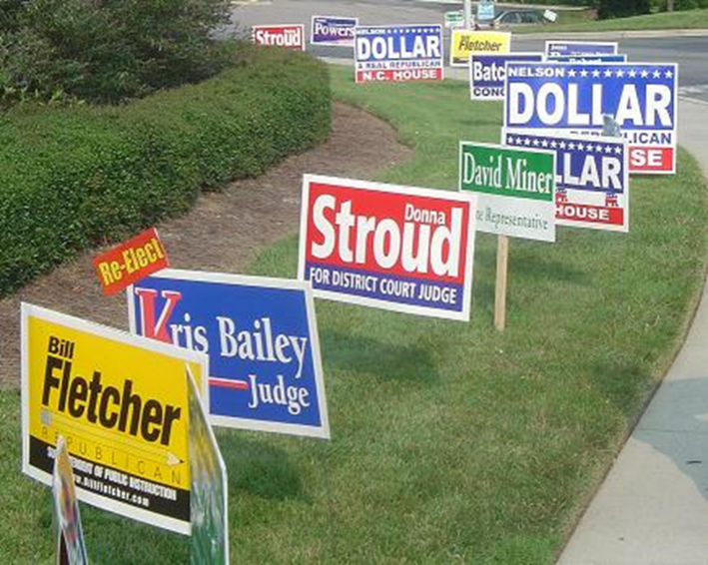No limit on duration of display, other than the mention of “a short time” in the definition
* Shall not exceed two per property at any one time
* In R-RU (Residential Rural), R-SF (Residential Single-Family), R-MN (Residential Mixed Neighborhood) and R-MH (Residential Mobile Home) zoning districts yard signs ***shall not exceed 12 square feet in area and shall not exceed four feet in height.***
* In all other zone districts yard signs***shall not exceed 32 square feet in area and eight feet in height****.*

**Prohibited signs in the City of Longmont:**

* Signs in rights-of-way or on other public property unless specifically permitted or provided for in the sign code
* Signs that cause visual obstruction or interfere with motor vehicle traffic or a traffic control device, including any sign that obstructs clear vision in any direction from any street intersection or driveway
* Inflatable signs such as balloons or inflatable figures, or other similar moving, fluttering, or revolving devices
* Signs on parked vehicles or trailers are prohibited unless
* Such vehicle or trailer is operational, currently registered with current tags, and parked in a functional parking space or behind a primary building
* Such signs are NOT located on top of a vehicle, except for delivery vehicles; and
* Such signs are NOT electronic message signs
* Signs painted on fences
* Signs attached to utility poles or other poles or structures, except bus stop signs, within public rights-of-way